**Potential Factors for Attrition**

**Overall Attrition rate for the given population is 16.1%**



**Hypothesis 1:** Employee who **travels frequently** have high chances of attrition.

Attrition rate when travel frequently=207 / (207+624) = **24.9%**

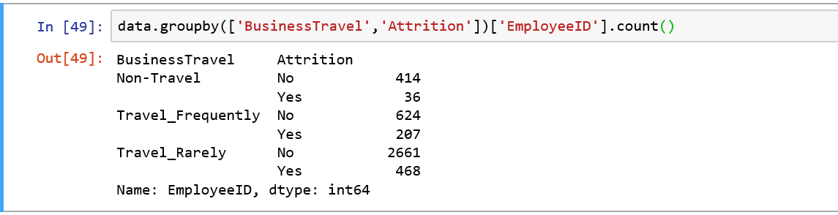

**Hypothesis 2:** Employee from **Human Resources** department have double the chances of Attrition as compared to other departments, however the volume of Attrition is low.

Attrition rate for HR department=57 / (57+132) = **30.1%**

Volume of Attrition for HR=57 / (57+453+201) = 8%



**Hypothesis 3**: **Marital Status** could be another factor for Attrition, **Single** Employees have higher attrition rate than others.

Attrition rate for Single Employees=360 / (360+1050)= **25.5%**

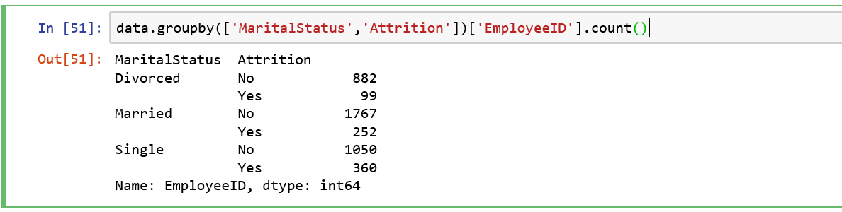

**Hypothesis 4**: Employees with **Educational Field** as **Human Resources** have higher chances of attrition, Technical degree and Other educational field have lower chances of Attrition.

Attrition rate for HR=33 / (33+48) = **40.7%**

Attrition rate for Technical Degree=45 / (45+351) = **11.3%**

Attrition rate for other= 30 / (30+216) = **12.19%**

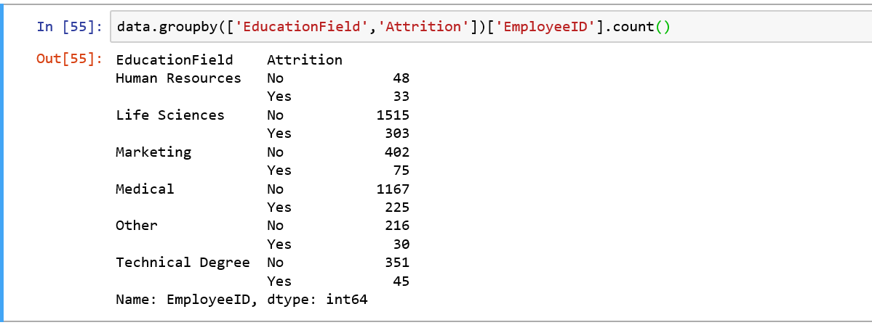

Univariate Analysis of all numerical variables where **Attrition = Yes**

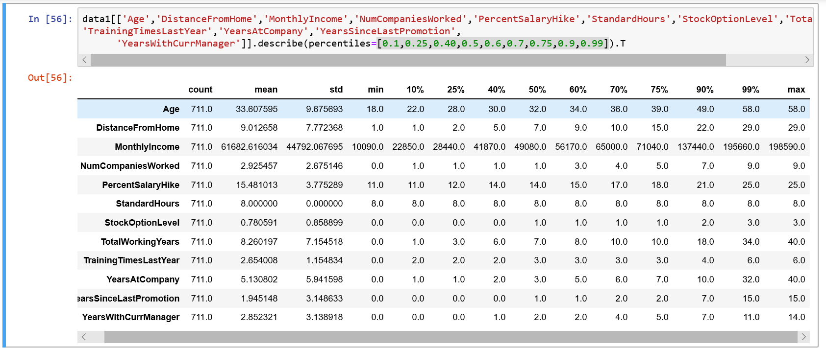

Univariate Analysis for **Attrition = NO**

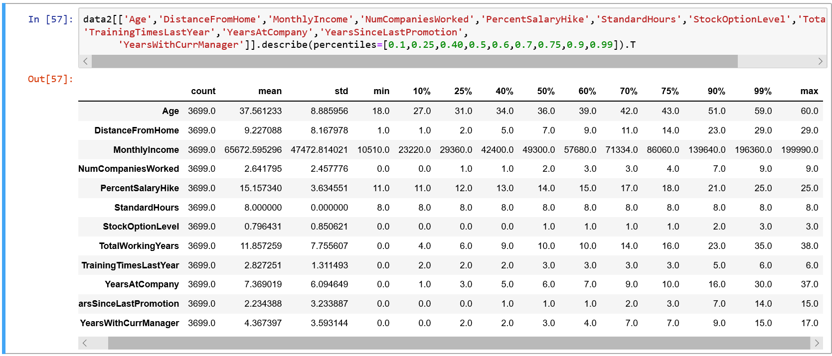

**Hypothesis 5: Age** could be one of the factor for Attrition.

Average age for Attrite Employees= **33.6**, Average age for non-Attrite Employees=**37.5**

**Hypothesis 6: Total working years** could justify reason for Attrition

Average of Total working years for Attrite Employees= **8.26**, Average of Total working years for non-Attrite Employees= **11.85**

**Hypothesis 7: Years at Company** could be another reason for Attrition

Average of Years at Company for Attrite Employees= **5.13**, Average of Years at Company for non-Attrite Employees= **7.36**

**Hypothesis 8: Years with current Manager** could show reason for Attrition

Average of Years with current Manager for Attrite Employees= 2.85, Average of Years with current Manager for non-Attrite Employees= 4.36

**Hypothesis 9:** **Gender** is not a significant factor for Attrition.

**Hypothesis 10:**

Variables like Distance from home, Monthly Income, Percent salary hike, Stock option level does not seem to have impact on Attrition because average for Attrite and non-attrite Employees are almost same.

**Other Inferences – Attrition Project**

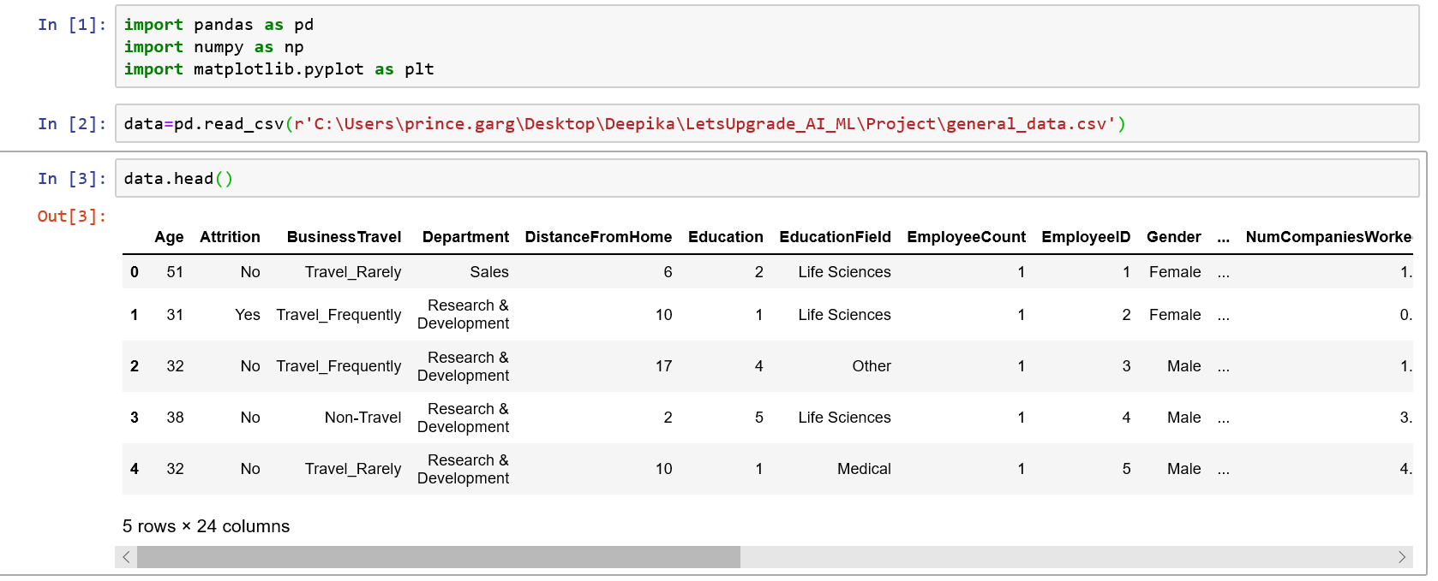

 No. of rows = 4416

No. of columns = 24

***Univariate Analysis:***

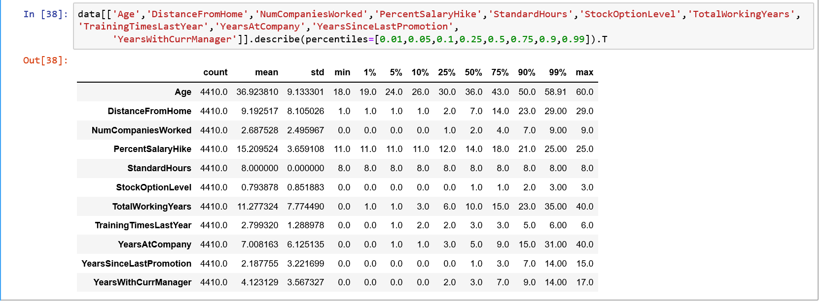

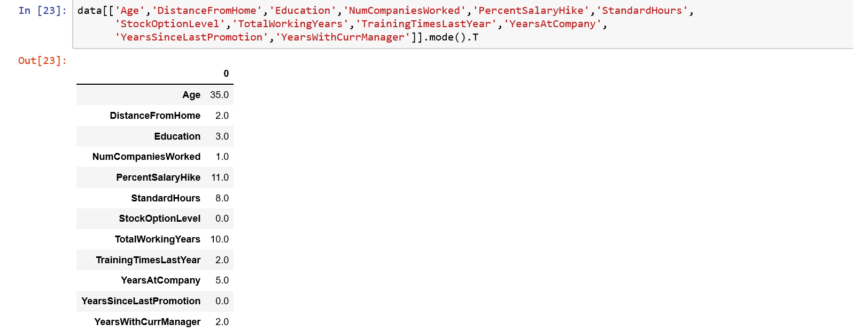

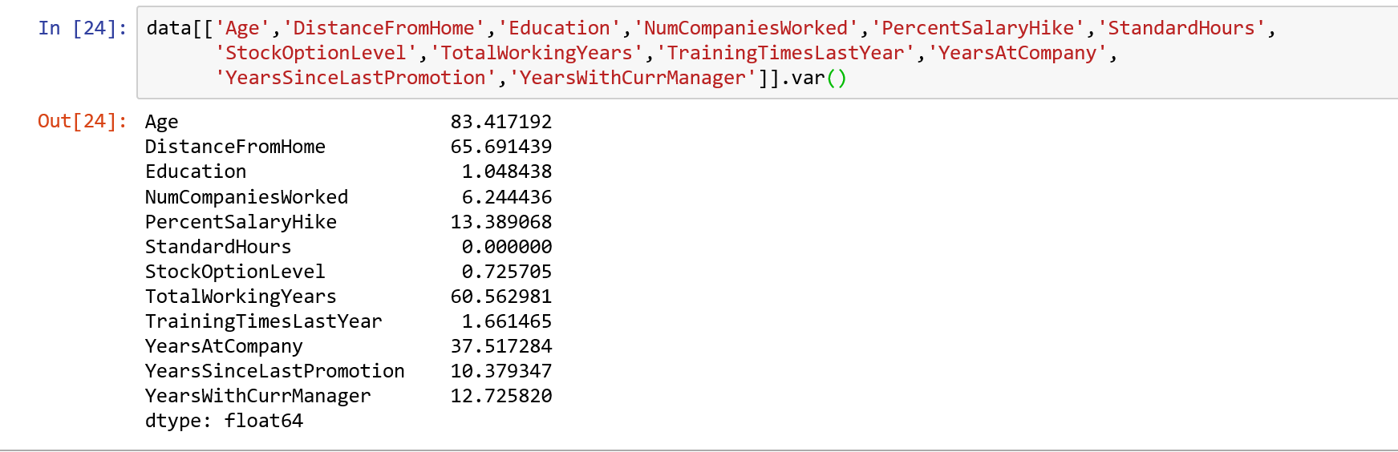

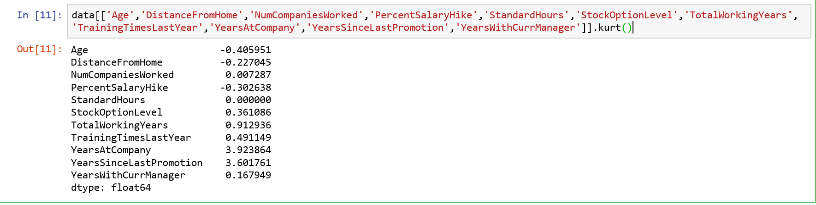 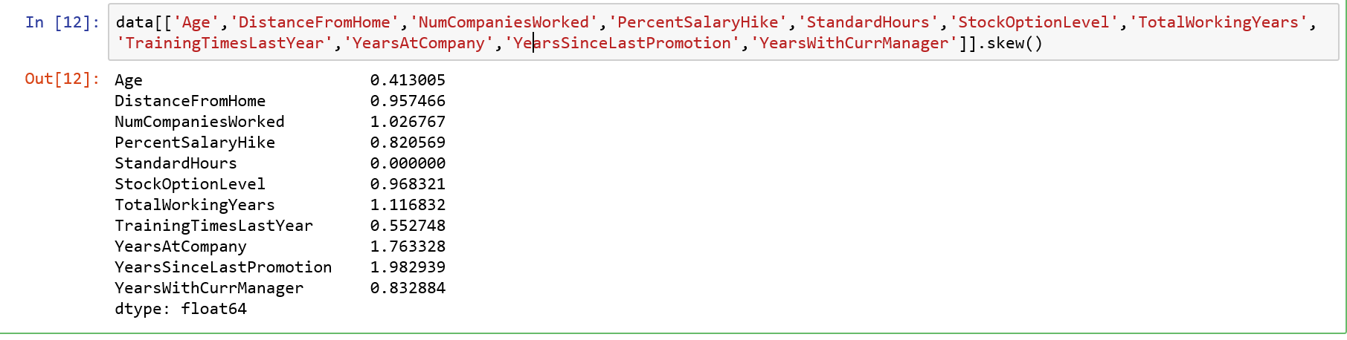

* *All above variables have positive values.*
* *This means all are positively skewed.*
* *mean > median*

***Checking Missing Values:***

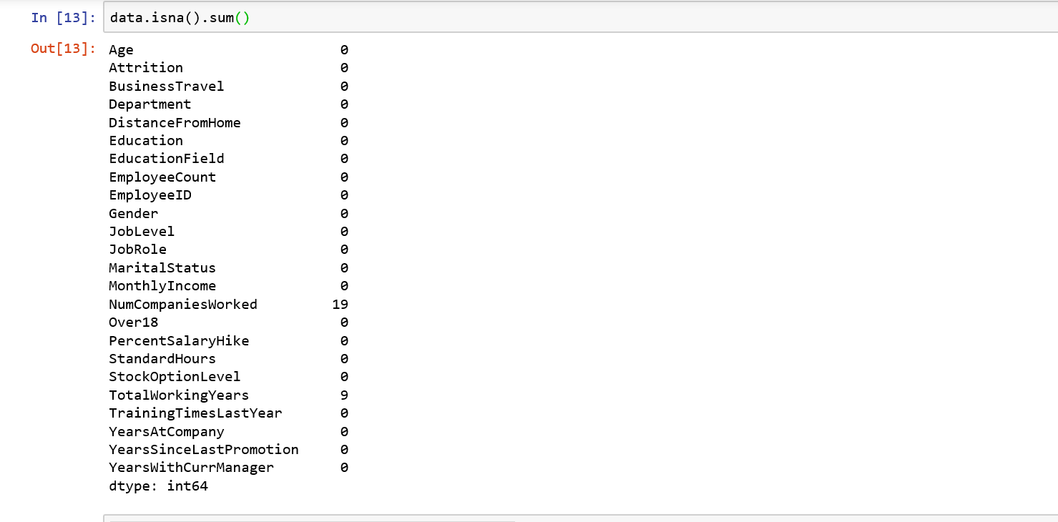

*As we can see only 2 variables has missing values.*

***Missing Values Imputation:***



***Outlier Detection:***

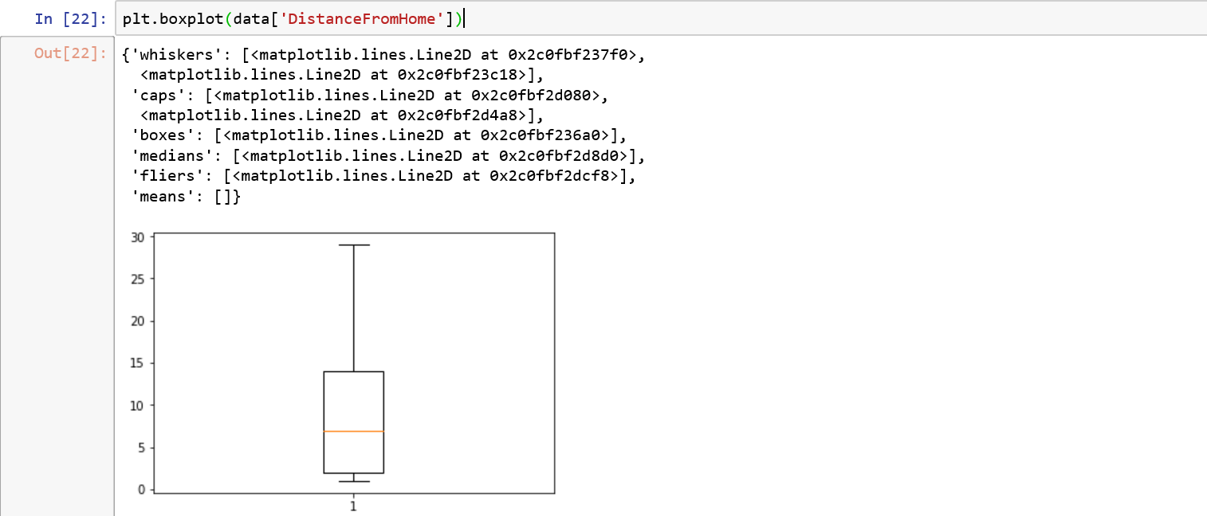

We can observe that for variable ‘DistanceFromHome’ there are no bubbles which means no outliers.

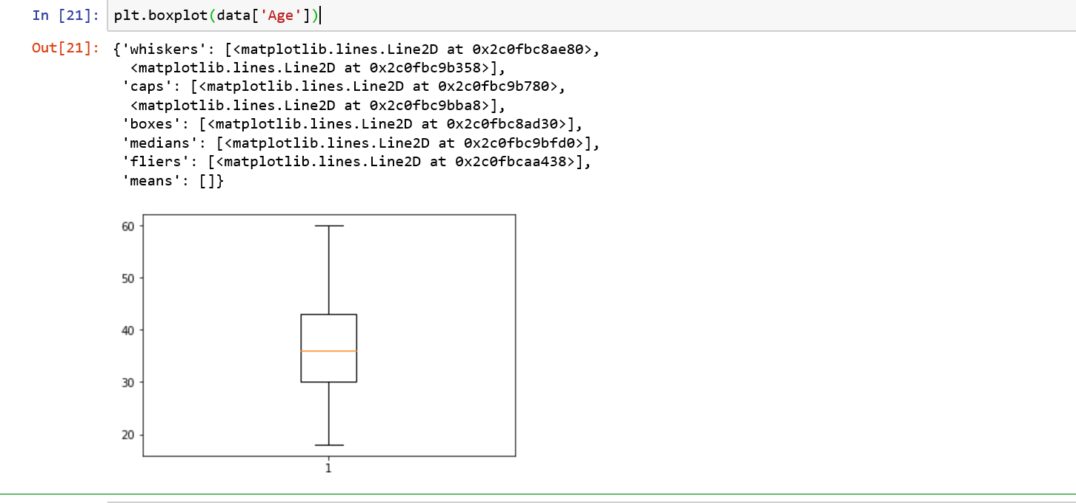

No outliers

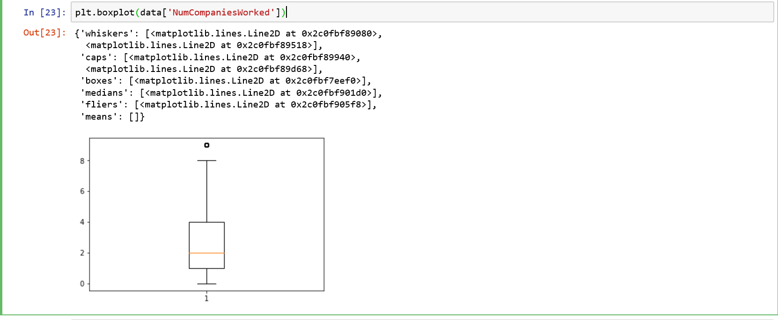

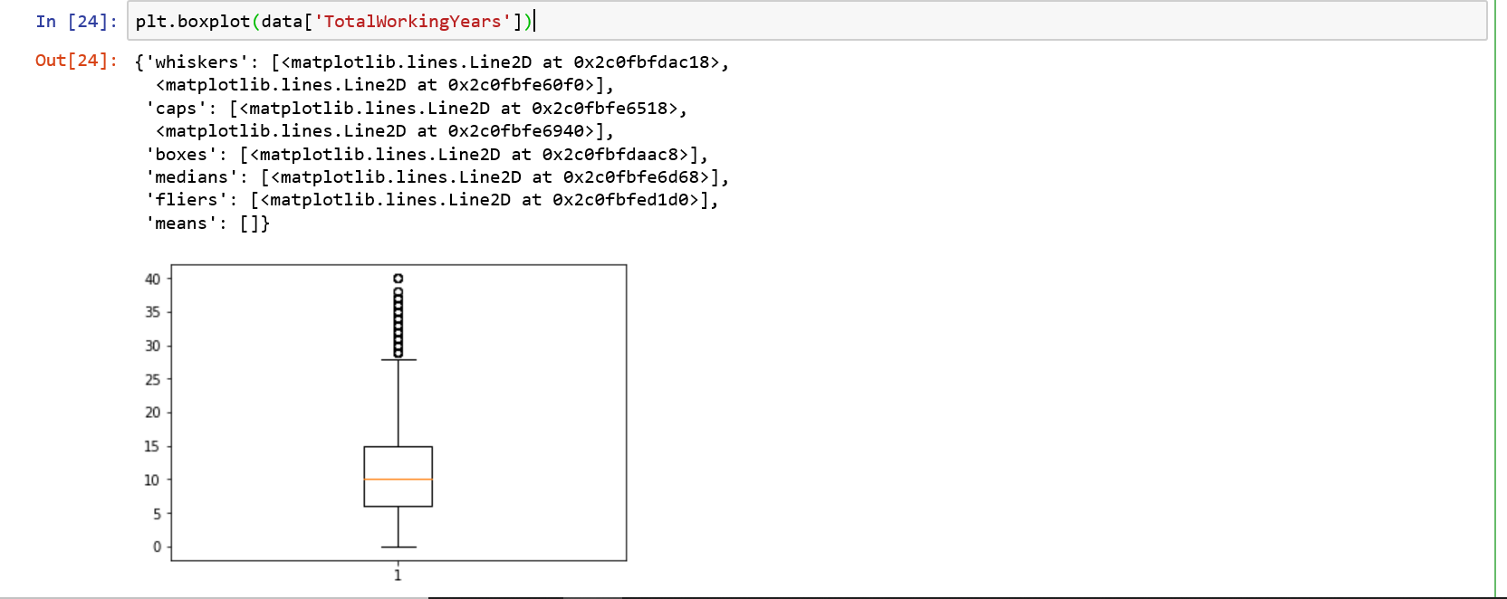

From above plot, we can see there are lot of bubbles which means the variable “Total Working Years” has outliers.

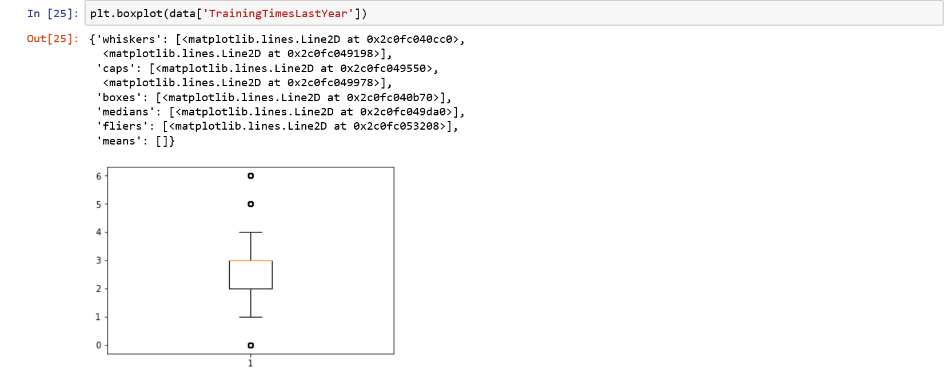

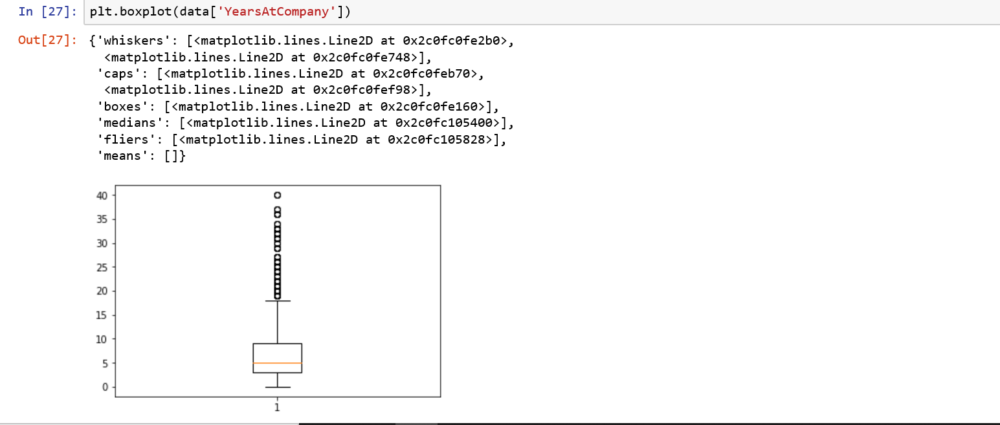

From above plot, we can see there are lot of bubbles which means the variable “Years at company” has outliers.

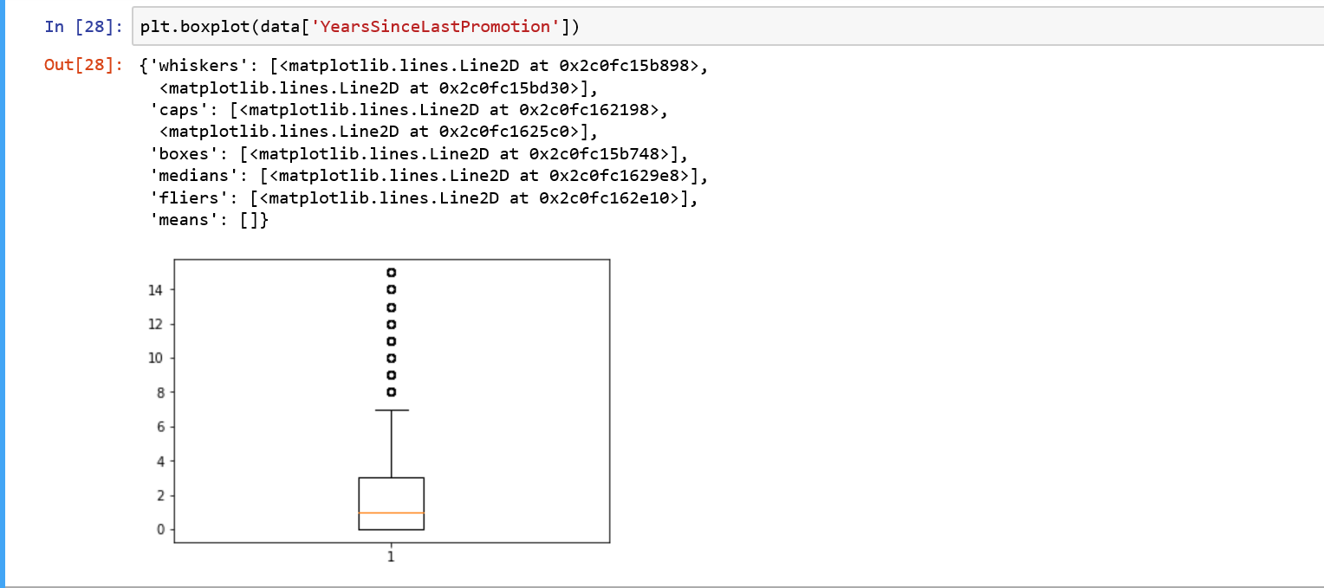

From above plot, we can see there are lot of bubbles which means the variable “Years Since last promotion” has outliers.

